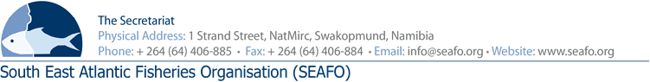

LIST OF DOCUMENTS FOR THE 12TH MEETING OF THE COMPLIANCE
COMMITTEE (CC) – 2019

CHAIRPERSON: Mr. Orlando Fachada (EU 2019-2020)
(Intersessional) / Mr. Kenro Iino (Japan) (Physical Meeting) VENUE: Strand Hotel, Swakopmund
VICE-CHAIR: Mr. Ryo Omori (Japan 2019-2020) DATE: 26 November 2019

Document Ref.  Number | Agenda  Item | Document Title | Provider | Availability of  Document
DOC/CC/00/2019 | All | List of Documents | Secretariat | Available before meeting
DOC/CC/01/2019 | All | Provisional Agenda of the 12th Annual Meeting of Compliance Committee | Secretariat | Available before meeting
DOC/CC/02/2019 | All | Provisional Annotated Agenda of the 12th Annual Compliance Meeting | Secretariat | Available before meeting
DOC/CC/03/2019 | 6 | Executive Secretary’s Report on Compliance for 2019 | Secretariat | Available before meeting
DOC/CC/04/2019 | 7 | Proposal for a correction in the SEAFO SYSTEM 2018 | Secretariat | Available before meeting
DOC/CC/05/2019 | 8 | Provisional IUU Vessel List for 2020 | Secretariat | Available before meeting
DOC/CC/06/2019  DOC/CC/07/2019 | 10 | SEAFO Fisheries Observer Training  Report May 2019  SEAFO Port Inspector Training Report June 2019 | Secretariat | Available before meeting

Circulation Date: 26 October 2019

